**Kyle Colangelo**

**Assignment 4**

Based on your code from the last assignment make the following modifications/changes:

* The AttackPoints method no longer has to return a value, unless you want it to.
* Modify the Villain and Hero classes to get assign a random number to the attack value every time AttackPoints is called.

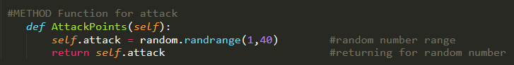

* Create a loop that prompts the user to runs a battle simulation until one of the opponents reach a life value of zero. Make sure to keep track of the rounds and battle number.

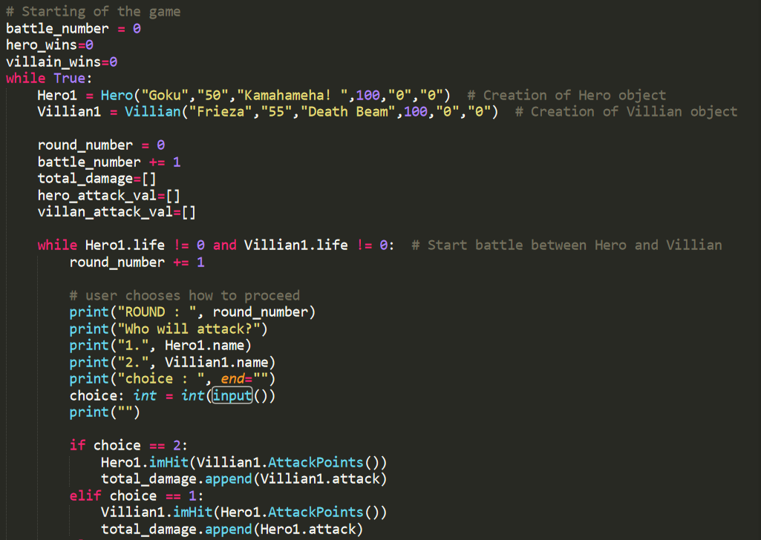

* The user should be asked if they would like to battle the Hero/Villain again once one is defeated (life reaches zero).

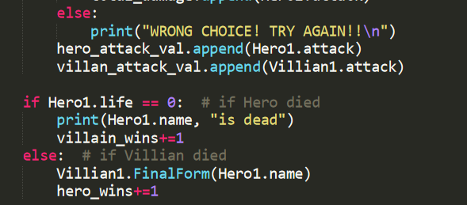

* Keep track of the number of Hero and Villian wins, until the user would like to exit. Keep track of the total damage done during each round.

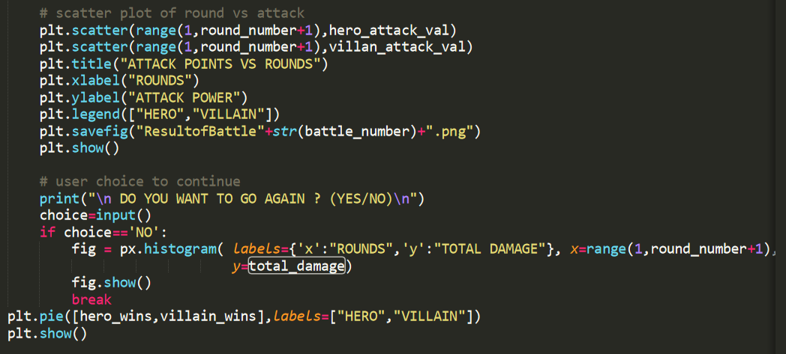

* After each battle create a scatterplot that plots the Hero and Villain values during the battle. The X axis should be the round number and the Y axis should be the attack value of the Hero/Villian during that round. Save this to a .png file with the name ResultofBattleX.png, where X is replaced with the battle number. Make sure to make the Hero and Villain points different colors. 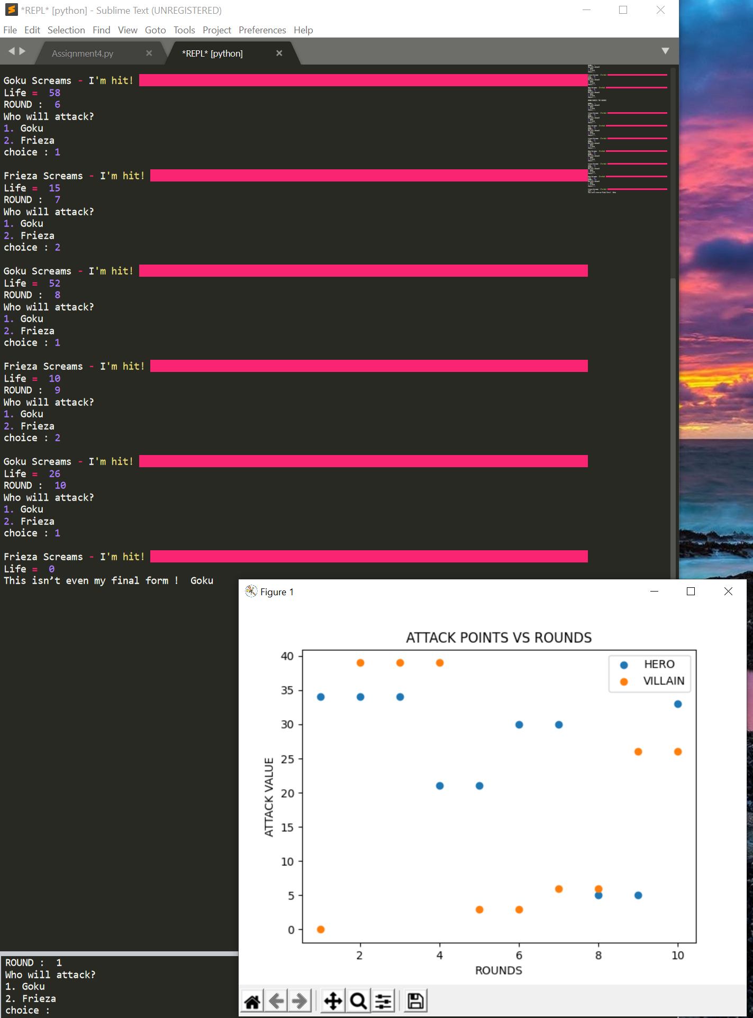
* When the user has enough bloodshed and would like to exit, after the exit  - create a pie graph with  the distribution of Hero wins versus Villian wins.

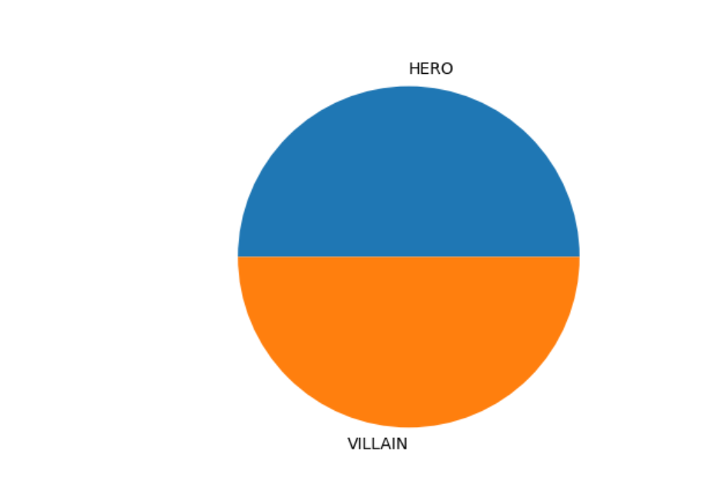

* For the last battle that was run, make a histogram with Plotly that has the total damage for the Y axis and round number for the X axis. Save this in a html file with a name of your choosing.

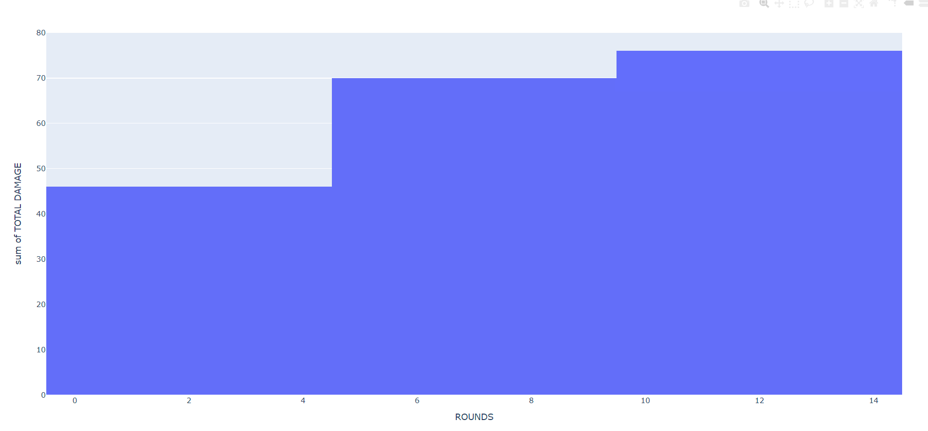

**Deliverables -Doc file, PNG files, and HTML file.**

Submit a doc file with the following:

* All your Python code.

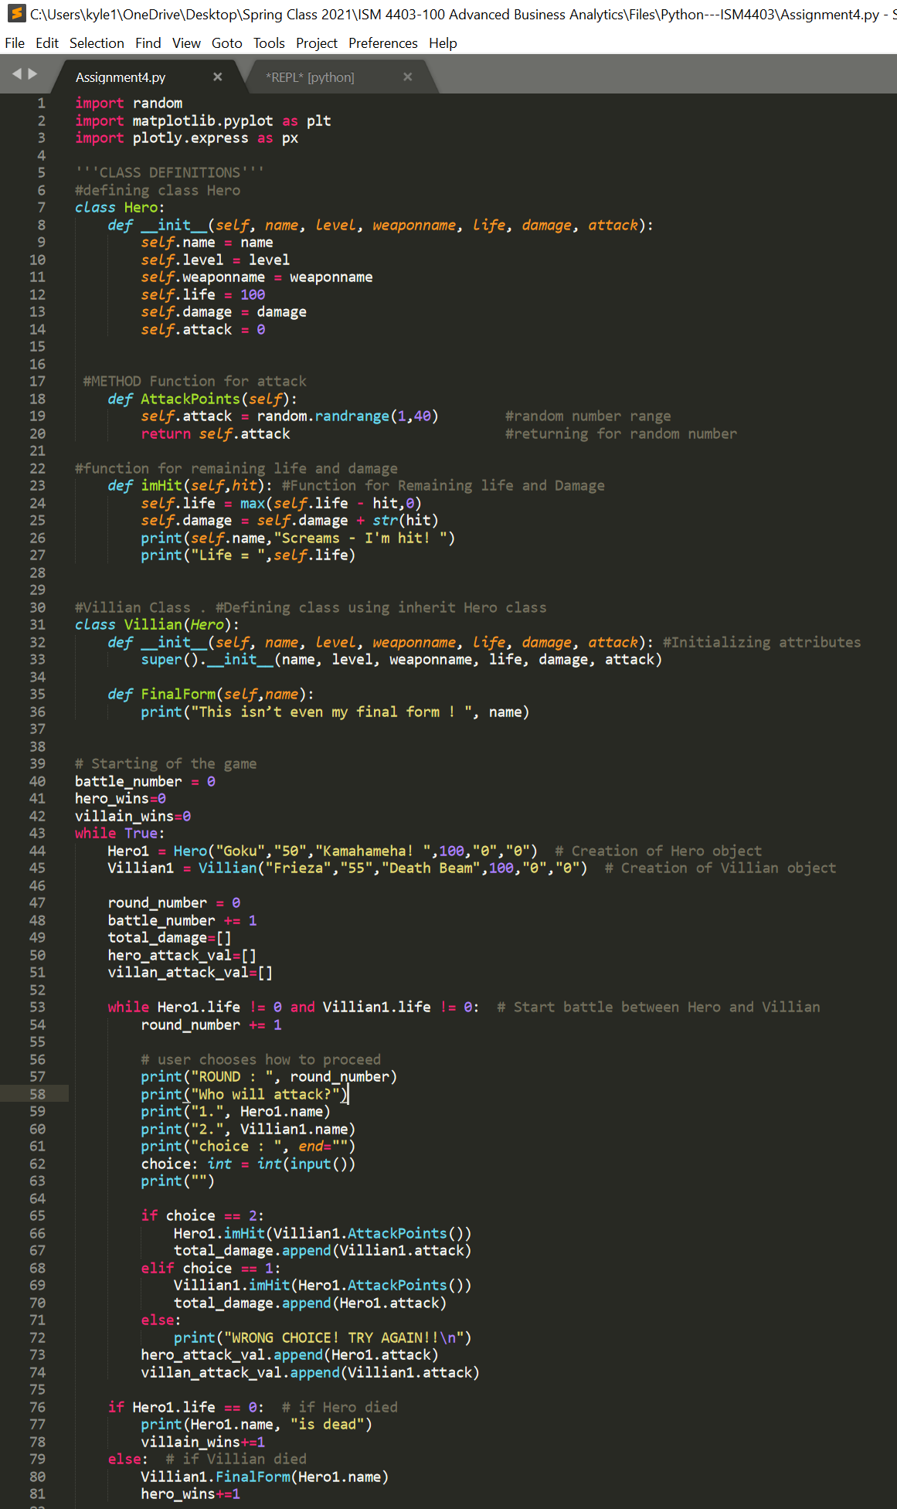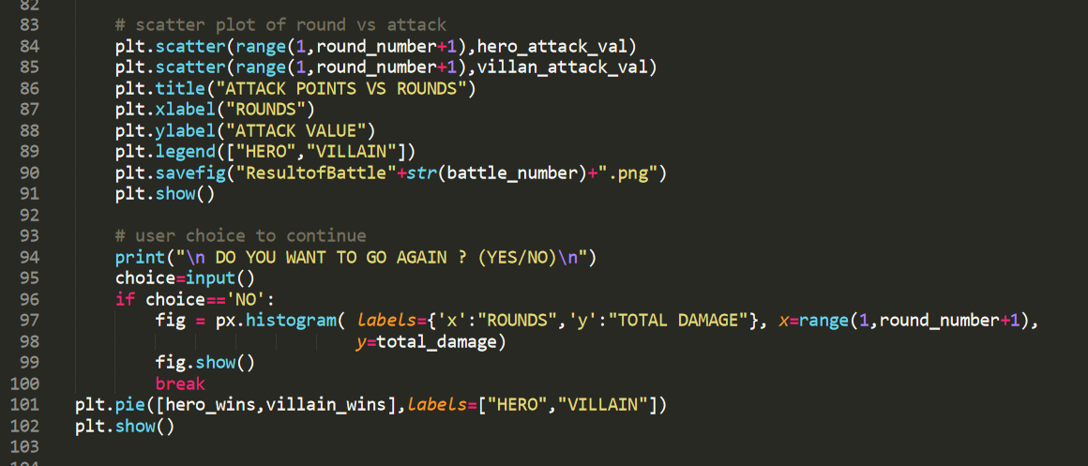

* Screen shots of the scatter plot image files for at least 5 battles.
* Screen shot of the pie chart showing the number of hero vs. villain wins.
* Screen shot of the results of the Plotly Histogram.

Submit a copy of all your png files.

Submit a copy of the HTML file.